Initial Entropy:
-(6/10)log₂(6/10) - (4/10)log₂(4/10) = 0.971

Department:
ISM:
-(4/6)log₂(4/6) - (2/6)log₂(2/6) = 0.918
IE:
-(2/4)log₂(2/4) - (2/4)log₂(2/4) = 1

0.971 – [(6/10)*0.918 + (4/10)*1] = 0.020
Master?
Yes:
3/3 for Y and N so = 1
No:
-(3/4)log₂(3/4) - (1/4)log₂(1/4) = 0.811

0.971 – [(6/10)*1 + (4/10)*0.811] = 0.047
Number of Courses:
<= 4:
-(4/5)log₂(4/5) - (1/5)log₂(1/5) = 0.722
>4:
-(2/5)log₂(2/5) - (3/5)log₂(3/5) = 0.971

0.971 – [(5/10)*0.722 + (5/10)*0.971] = 0.124

b)
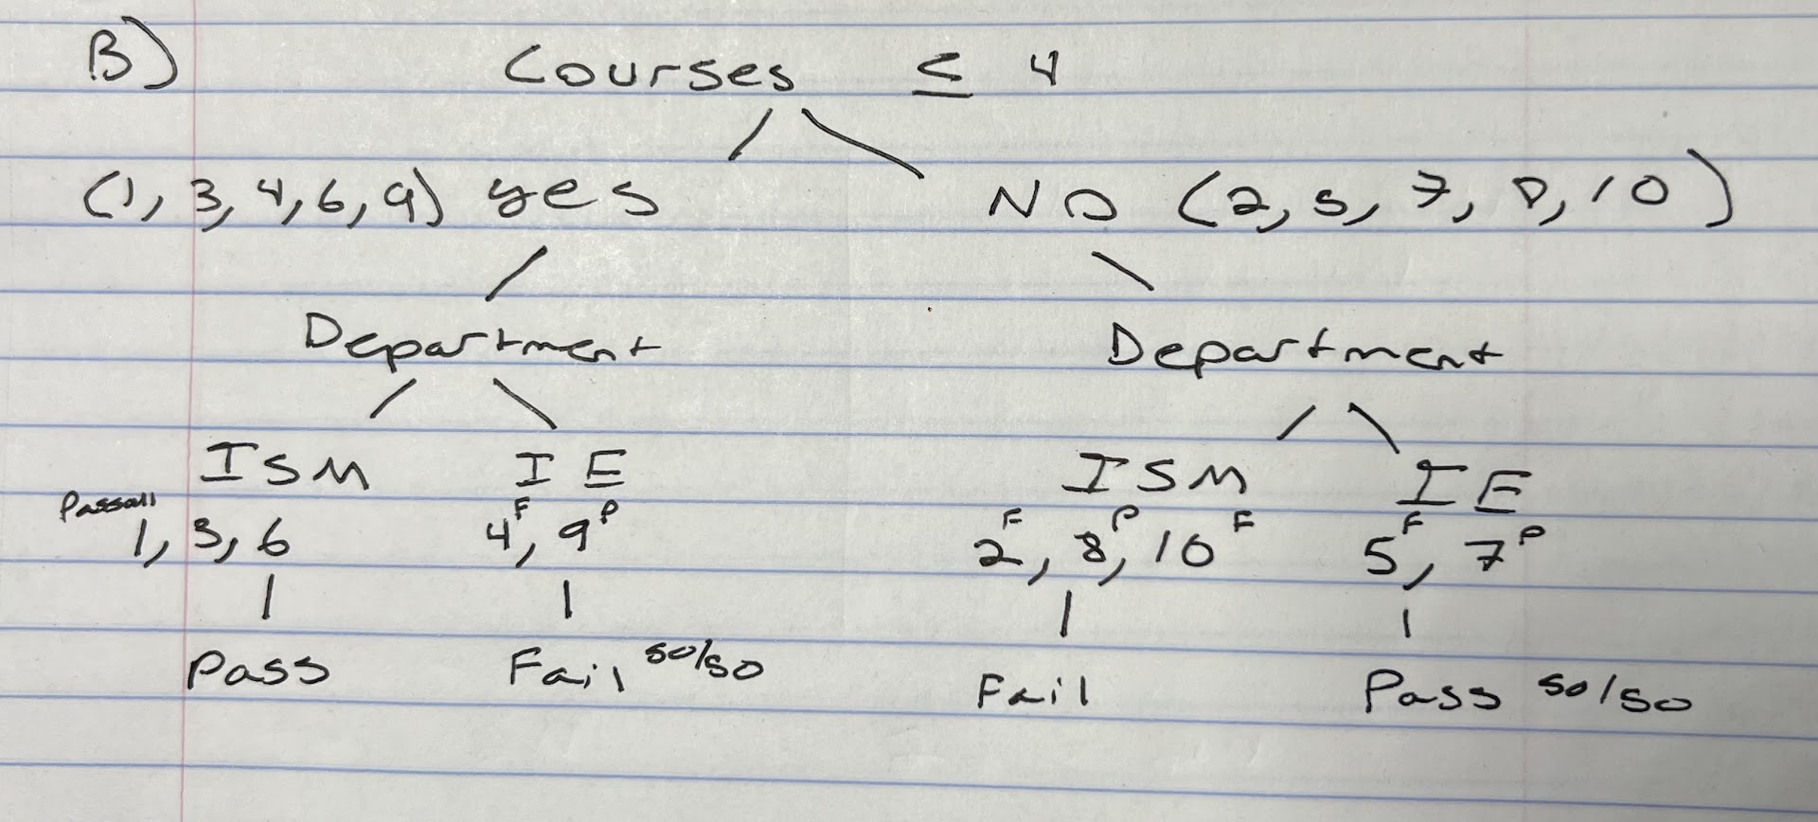

c)
Rule 1: If a student takes 4 or less courses and is in the ISM department they will pass, the justification is that 3/3 of the students who went this route in our sample passed.

Rule 2: If a student takes more than 4 classes and is in the ISM department then they will fail, the justification is that 2/3 of the students who went this route in our sample failed.

d)
Masters:
Yes:
- - [(3/6)² + (3/6)²] = 1 – [1/4 + 1/4] = 0.5
No:
1 - [(3/4)² + (1/4)²] = 1 – [9/16 + 1/16] = 0.375

[(6/10)*0.5 + (4/10)*0.375 = 0.3 + 0.15 = 0.45
0.48 – 0.45 = 0.03
Number of Courses:
Yes:
- - [(4/5)² + (1/5)²] = 1 – [16/25 + 1/25] = 0.32
No:
1 - [(2/5)² + (3/5)²] = 1 – [4/25 + 9/25] = 0.48

[(5/10)*0.32 + (5/10)*0.48 = 0.16 + 0.24 = 0.40
0.48 – 0.40 = 0.8

